

**TESTO PIZZA**

|  |  |  |
| --- | --- | --- |
| **Supervisor:** | *LÊ THANH NHÂN* | |
| **Semester:** | *II* | |
| **Batch No:** | *T1.2206.E1* | |
| **Group No:** | *03* | |
| **Order:** | **Full name** | **Roll No.** |
| *1.* | *Phan Quốc Thái* | *Student1381855* |
| *2.* | *Cao Tiến Nam* | *Student1387832* |
| *3.* | *Trương Ngô Mạnh Đan* | *Student1387827* |
| *4.* | *Phan Nguyễn Hưng* | *Student1376116* |

***Month****: 03* ***Year****: 2023*



This is to certify that

|  |  |
| --- | --- |
| **Mr.** | **PHAN QUỐC THÁI** |
| **Mr.** | **CAO TIẾN NAM** |
| **Mr.** | **TRƯƠNG NGÔ MẠNH ĐAN** |
| **Mr.** | **PHAN NGUYỄN HƯNG** |

Have successfully Designed & Developed

|  |  |  |
| --- | --- | --- |
|  |  |  |
| **TESTO PIZZA** | | |

Submitted by:

|  |
| --- |
| **Mr. LE THANH NHAN** |

Date Of Issue:

|  |  |
| --- | --- |
|  |  |

Authorized Signature:

|  |  |
| --- | --- |
|  |  |
| **Content** | | | |

Content

Acknowledge

Synposis

Review1 (điền số trang theo thực tế)

Review2 (điền số trang theo thực tế)

Review3 (điền số trang theo thực tế)

Testting Document (điền số trang theo thực tế)

Final Checklist (điền số trang theo thực tế)

Tasksheet (điền số trang theo thực tế)

|  |
| --- |
| **Acknowledge** |

As we understand that the Project is a step-by-step learning environment that closely simulates the class-room and Lab based learning environment into actual implementation. It is a projectimplementation at your fingertips!! An electronic, live juncture on the machine that allows you to.

✓ Practice step by step i.e. laddered approach.

✓ Build a larger more robust application.

✓ Usage of certain utilities in applications designed by user.

✓ Single program to unified code leading to a complete application.

✓ Learn implementation of concepts in a phased manner.

✓ Enhance skills and add value.

✓ Work on real life projects.

✓ Give a real life scenario and help to create applications more complicated and useful.

✓ Mentoring through email support.

We would like to send a great thank to our professor, Mr Le Thanh Nhan and others student for the addorable supports during the time in project.

Beside serveral mistakes we had made in the project, we hope to have more oppotunities to widen our knownledge in web developing world.

We also thank you so much for your infomation and the “demo” project from India APTECH to help us get more reality experience in this project. Since we have gained more experience from this project, we will not stop learning any thing as much as we can to be more successful in the future.

Your Sincerely,

Team Group 03.

|  |
| --- |
| **Synposis** |

The Objective of this program we aim is to give a sample project to work on real  
life projects. These applications help us build a larger more robust application.

The objective is not to teach us front-end or back-end technology but to provide us with a real life scenario and help us create basic applications using the tools.

Hence, we can revise the chapters before we start with the project.

This project is meant for students like us who have completed the module of  
Semester II, as well as special subjects those are Java and PHP. These programs should  
be done in the Lab sessions with assistance of the faculty if required.

The website (in this project) is a world that brings everything about the potteries  
and crockeries into your experience.

It is very essential for us that will have a clear understanding of the subject. We  
think we should go through the project and solve the assignments as per requirements  
given.

**Review 01**

|  |
| --- |
| **Problem Definition** |

Founded in 2020, Testo Pizza by Testo Inc. – Italian-inspired restaurant chain has been expanding its restaurants and franchise system world. In 2020, Testo Pizza launched its very first restaurant in Vietnam. Together with the opened trading trend, Testo Pizza is one of the pizza brands that has a significant development in Vietnam with more restaurants throughout the nation and becomes a favorite place for Vietnamese customers for the past 2 years. However, they are facing a problematic issue, mostly because of the huge number of people going to their outlets on a daily basis. It is now rather hard for their employees to serve each customer properly in an overcrowded joint. If they open more restaurants, it will certainly put a great financial burden on their budget. That’s why the board of directors in Testo Pizza has decided to launch a website in order for their customers to order pizzas online with ease. Besides, all of the food orders and food items will be managed by a system whose access is granted to Testo's administrators. Their expectations for the websites are as follows:

***For the visitor’s website***

* A home page will brief about the company, also design a suitable logo and include it on home page, you may display the logo on all the pages in the site.
* A menu which will include all the functions implemented in the site.
* A catalogue should be provided to help visitors choose and order their desired pizzas and other food items.
* A shopping cart will store visitors’ orders and print the bill after they check out.
* A store page will show the address list of Testo Pizza.’s joints along with their locations on the map.
* A feedback page allows visitors to express their reviews on the quality of services from Testo Pizza.

***For the admin’s website***

* A login page will grant access to Testo Pizza.’s admins or the webmaster.
* A management page for Testo Pizza.’s admins will be used to insert, delete, or update the menu of Testo Pizza.’s as well as keep track of customers’ orders, account info and feedback.
* A management page for Webmaster to insert, update, delete the accounts of Testo Pizza.’s admins based on its executives.

|  |
| --- |
| **Customer Requirements Specifications** |

**Client:** Testo Inc.

**Business / Project objective:** Build the website “testo.com” that meets with Testo Inc.’s expectations and requirements.

**Input to the system:**

* **Testo Inc.’s executives need to:**
* Provide a list of food items and their description (name, food type, price, etc.).
* Webmaster ask admin to give their basic data (admin ID, name, email, password) to create accounts for the admin’s website login.
* **Website’s visitors need to:**
* Provide their personal data to sign up as a member.
* Select food items to order.
* Provide the required information for delivery if they don’t apply default delivery address of membership.
* Give ratings to their food items and express their opinions on the feedback page..

**Process of the system:**

* **From the admin’s website:**
* Process registration data of admin.
* **From the visitor’s website:**
* Process customer login/registration data.
* Process product’s rating and review.
* Process customer orders.
* Handle customer contact and respond to customers via Email.

**Output from the system:**

* **From the admin’s website:**
* Display requested information (food items, customer orders, customer feedback, etc.) from the database based on admin’s preferences.
* Display functions for manipulating database provided by the system (create, edit, delete, etc.).
* Display a list of existing admin accounts (for Webmaster only).
* **From the visitor’s website:**
* Display a menu containing available food items categorized by their type (pizza, sides, drinks, etc.).
* Update the shopping cart after visitors’ selections.
* Print the bill after visitors check out.
* Show account details for visitors who log in into the website.
* Display forms for visitors to sign up, log in, edit their membership details, and give their reviews on the services offered by Testo Pizza.

**Hardware requirement:**

- Processor 1 GHz or faster

- Display of 800x600 resolution or better

- 512 MB RAM or better

**Software requirement:**

- Windows 7 or higher

- NetBean 8.2

- PHP 7.0 or above - MySQL.

- IE (8.0 or abovea) / Google Chrome/Mozilla Firefox browsers

**Sever side Softwear requirements:**

- XAMPP Server

- IIS 5.0 websever or later

**Review 02**

|  |
| --- |
| **Data Flow Diagram** |

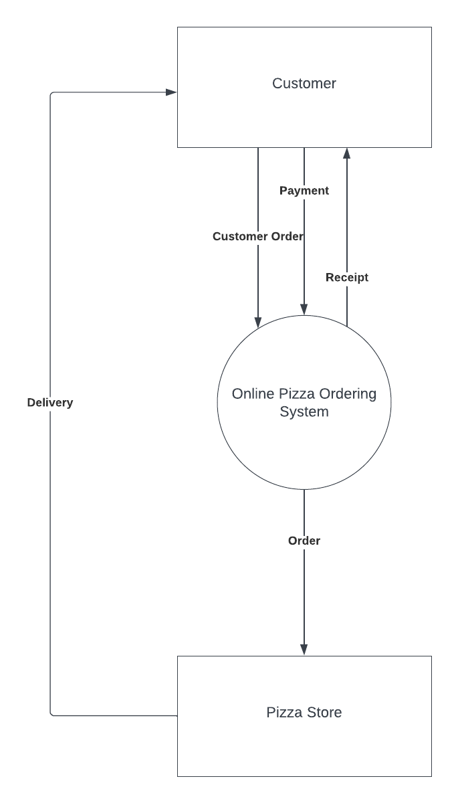

|  |
| --- |
| **A. Entity Relationship Diagram** |

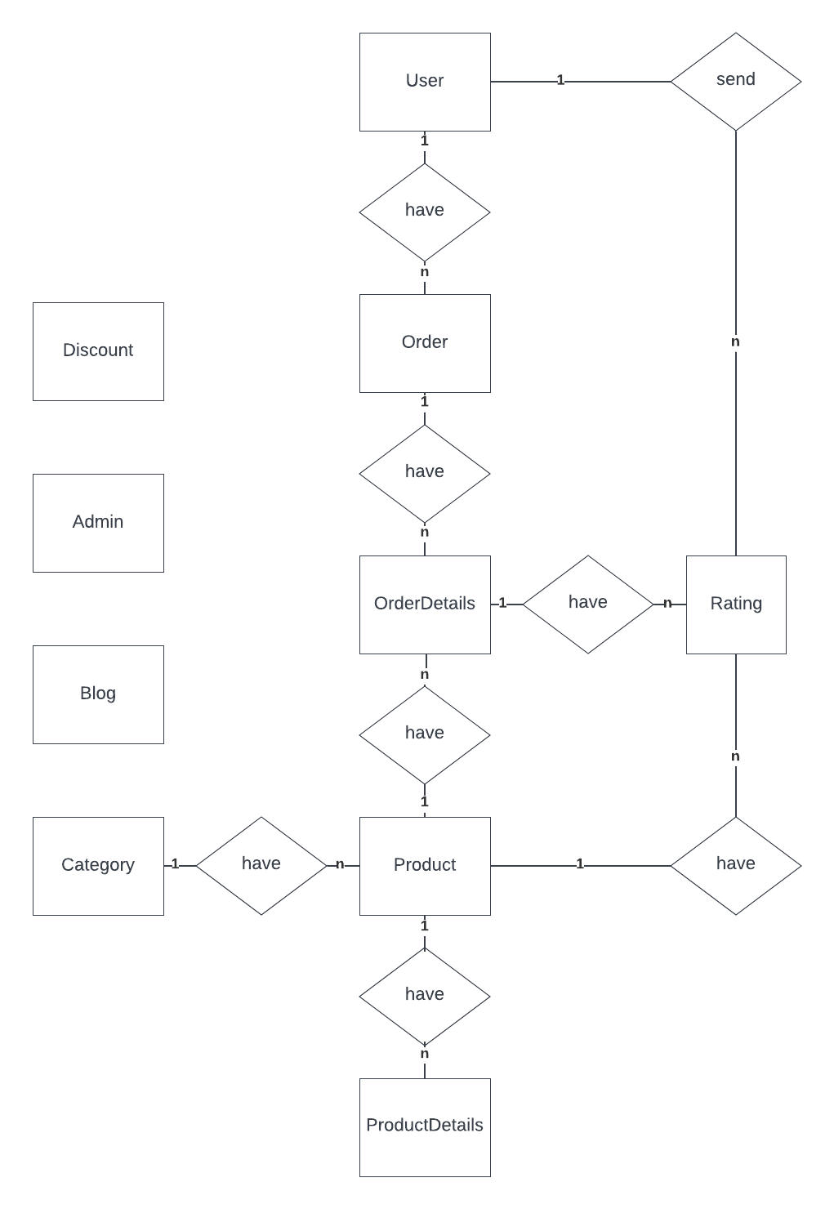

|  |
| --- |
| **B. Entity Attributes** |

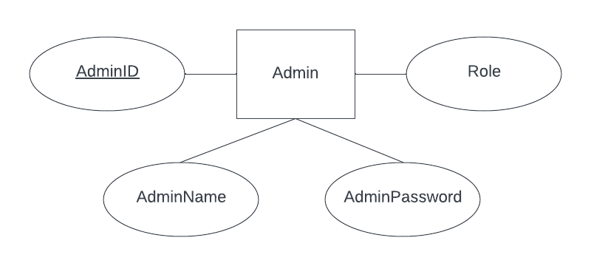

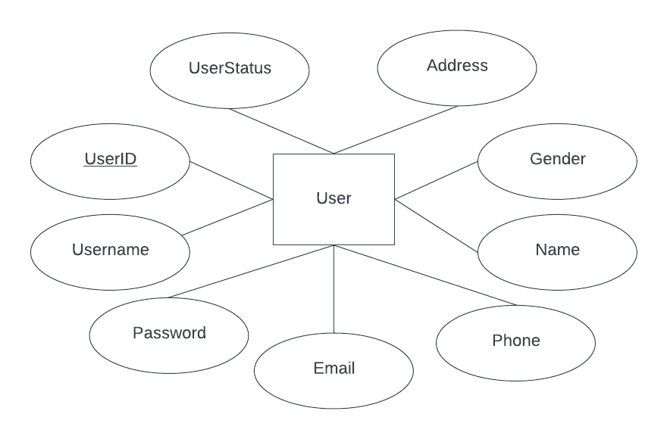

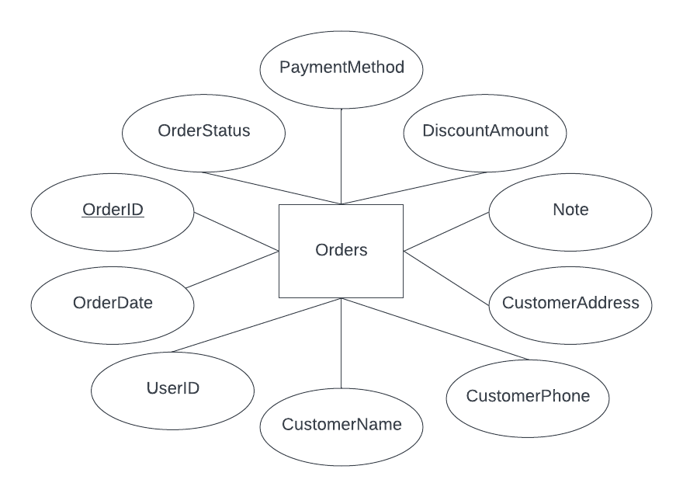

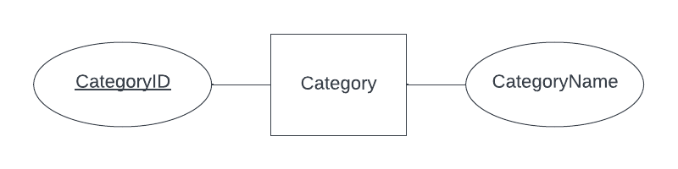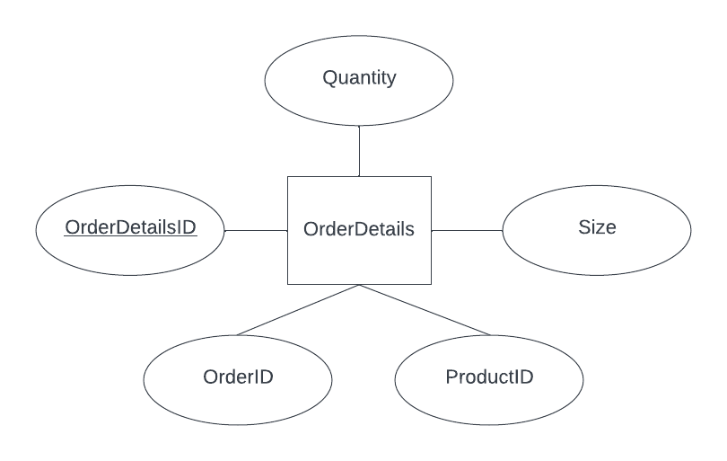

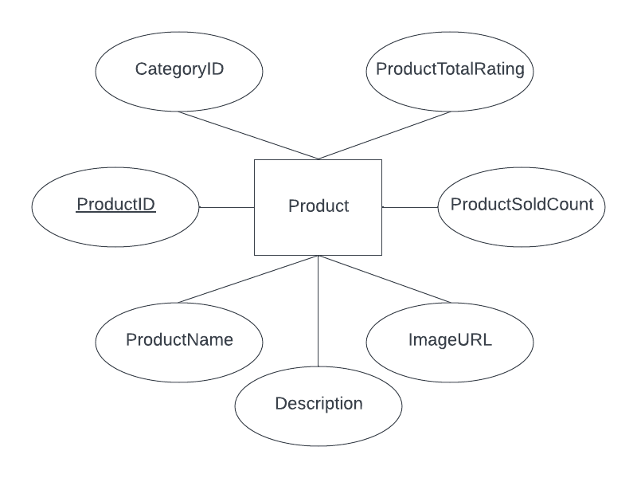

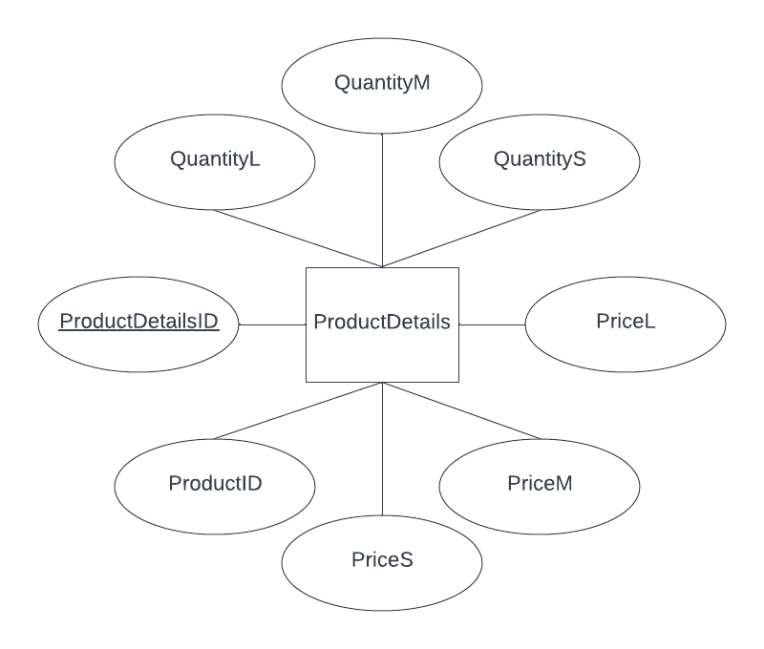

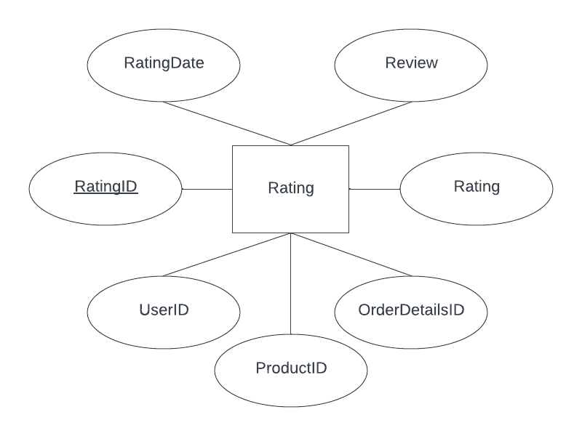

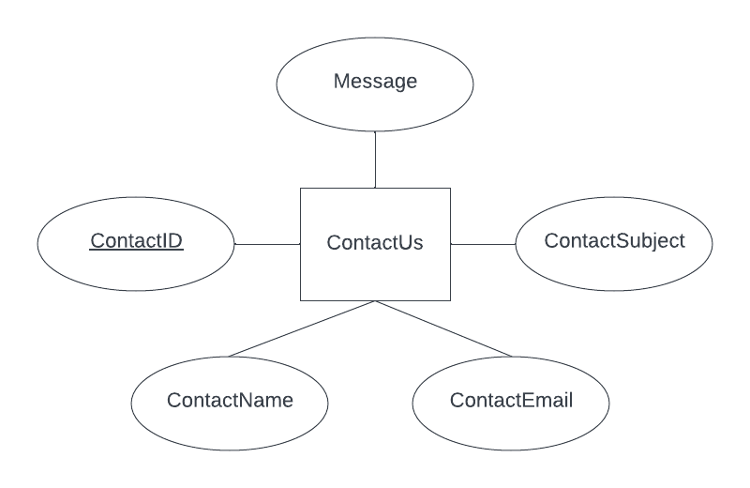

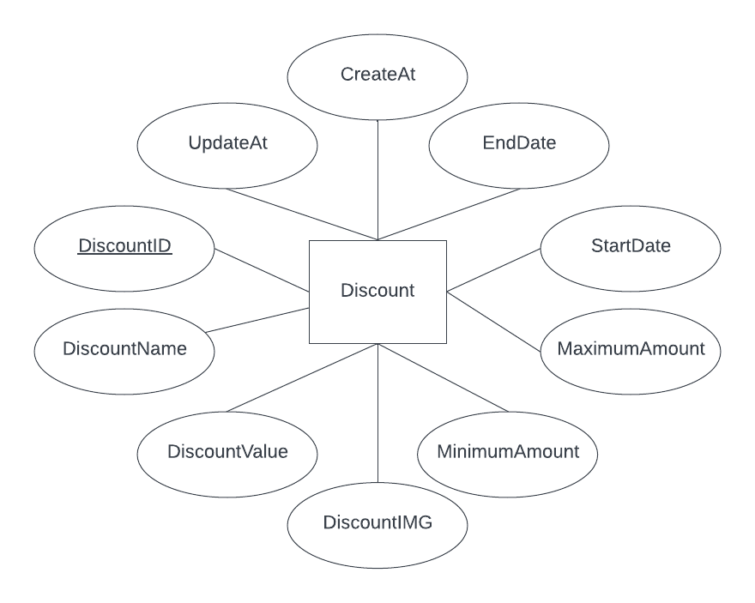

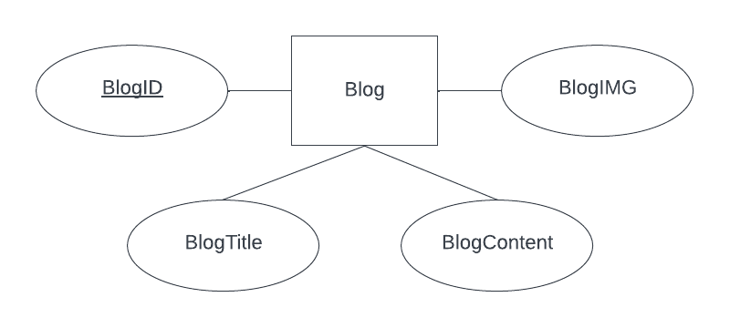

|  |
| --- |
| **A. Table Design** |

|  |  |  |  |  |  |
| --- | --- | --- | --- | --- | --- |
| **Admin** | | | | | |
| **Serial** | **Fields** | **Data type** | **Keys** | **Constrains** | **Description** |
| 1 | AdminID | int | Primary Key | not null, auto increment | AdminID's number |
| 2 | AdminName | varchar(50) |  | not null | Admin name to login |
| 3 | AdminPassword | varchar(255) |  | not null | Admin's password |
| 4 | Role | tinyint |  | not null | Admin owner's role |

|  |  |  |  |  |  |
| --- | --- | --- | --- | --- | --- |
| **User** | | | | | |
| **Serial** | **Fields** | **Data type** | **Keys** | **Constrains** | **Description** |
| 1 | UserID | int | Primary Key | not null, auto increment | UserID's number |
| 2 | Username | varchar(50) |  | not null, unique | User name to login |
| 3 | Password | varchar(255) |  | not null | User's password |
| 4 | Email | varchar(255) |  | not null, unique | User's email |
| 5 | Phone | varchar(255) |  | not null, unique | User's phone number |
| 6 | Name | varchar(255) |  | not null | User's name |
| 7 | Gender | enum |  | not null | User's gender |
| 8 | Address | varchar(255) |  | not null | User's address |
| 9 | UserStatus | enum |  | not null | User's status |

|  |  |  |  |  |  |
| --- | --- | --- | --- | --- | --- |
| **Category** | | | | | |
| **Serial** | **Fields** | **Data type** | **Keys** | **Constrains** | **Description** |
| 1 | CategoryID | int | Primary Key | not null, auto increment | Category's number |
| 2 | CategoryName | varchar(255) |  | not null | Category's name |

|  |  |  |  |  |  |
| --- | --- | --- | --- | --- | --- |
| **Product** | | | | | |
| **Serial** | **Fields** | **Data type** | **Keys** | **Constrains** | **Description** |
| 1 | ProductID | int | Primary Key | not null, auto increment | ProductID's number |
| 2 | ProductName | varchar(255) |  | not null | Product's name |
| 3 | Description | text |  |  | Product's description |
| 4 | ImageURL | varchar(255) |  | not null | Product's image url |
| 5 | ProductSoldCount | int |  | not null | Product sold count |
| 6 | ProductTotalRating | float |  | not null | Product rating |
| 7 | CategoryID | int | Foreign Key | not null | Category number |

|  |  |  |  |  |  |
| --- | --- | --- | --- | --- | --- |
| **ProductDetails** | | | | | |
| **Serial** | **Fields** | **Data type** | **Keys** | **Constrains** | **Description** |
| 1 | ProductDetailsID | int | Primary Key | not null, auto increment | Product details's number |
| 2 | ProductID | int | Foreign Key | not null | ProductID number |
| 3 | PriceS | decimal(10, 2) |  |  | PizzaS’s price |
| 4 | PriceM | decimal(10, 2) |  | not null | PizzaM/Product’s price |
| 5 | PriceL | decimal(10, 2) |  |  | PizzaL’s price |
| 6 | QuantityS | int |  |  | PizzaS’s quantity |
| 7 | QuantityM | int |  | not null | PizzaM/Product’s quantity |
| 8 | QuantityL | int |  |  | PizzaL’s quantity |

|  |  |  |  |  |  |
| --- | --- | --- | --- | --- | --- |
| **Discount** | | | | | |
| **Serial** | **Fields** | **Data type** | **Keys** | **Constrains** | **Description** |
| 1 | DiscountID | varchar(20) | Primary Key | not null | DiscountID's number |
| 2 | DiscountName | varchar(255) |  | not null | Discount's name |
| 3 | DiscountValue | varchar(255) |  | not null | Discount's value |
| 4 | DiscountIMG | varchar(255) |  |  | Discount's image url |
| 5 | MinimumAmount | decimal(10, 2) |  | not null | Lowest order's value to use discount |
| 6 | MaximumAmount | decimal(10, 2) |  | not null | Maximum reduction's value |
| 7 | StartDate | datetime |  | not null | Date start discount |
| 8 | EndDate | datetime |  | not null | Date end discount |
| 9 | CreateAt | datetime |  | not null | Date create discount |
| 10 | UpdateAt | datetime |  |  | Date update discount |

|  |  |  |  |  |  |
| --- | --- | --- | --- | --- | --- |
| **Orders** | | | | | |
| **Serial** | **Fields** | **Data type** | **Keys** | **Constrains** | **Description** |
| 1 | OrderID | varchar(255) | Primary Key | not null | OrderID's string |
| 2 | OrderDate | datetime |  | not null | Date customer place order |
| 3 | UserID | int | Foreign Key | not null | UserID's number |
| 4 | CustomerName | varchar(255) |  | not null | Customer's name |
| 5 | CustomerPhone | varchar(255) |  | not null | Customer's phone |
| 6 | CustomerAddress | varchar(255) |  | not null | Customer's address |
| 7 | Note | text |  |  | Order's note |
| 8 | DiscountAmount | decimal(10, 2) |  |  | Discount amount |
| 9 | PaymentMethod | decimal(10, 2) |  | not null | Payment’s method |
| 10 | OrderStatus | varchar(255) |  | not null | Order's status |

|  |  |  |  |  |  |
| --- | --- | --- | --- | --- | --- |
| **OrderDetails** | | | | | |
| **Serial** | **Fields** | **Data type** | **Keys** | **Constrains** | **Description** |
| 1 | OrderDetailsID | int | Primary Key | not null, auto increment | Order Details's number |
| 2 | OrderID | datetime | Foreign Key | not null | OrderID's number |
| 3 | ProductID | int | Foreign Key | not null | ProductID's number |
| 4 | Size | varchar(255) |  |  | Pizza’s size |
| 5 | Quantity | varchar(255) |  | not null | Product's quantity |

|  |  |  |  |  |  |
| --- | --- | --- | --- | --- | --- |
| **Rating** | | | | | |
| **Serial** | **Fields** | **Data type** | **Keys** | **Constrains** | **Description** |
| 1 | RatingID | int | Primary Key | not null, auto increment | RatingID's number |
| 2 | UserID | int | Foreign Key | not null | UserID's number |
| 3 | ProductID | int | Foreign Key | not null | ProductID's number |
| 4 | OrderDetailsID | int | Foreign Key | not null | OrderDetailsID's number |
| 5 | Rating | int |  | not null | Customer’s rating product |
| 6 | Review | varchar(255) |  |  | Feedback product of customer |
| 7 | RatingDate | datetime |  | not null | Date customer rating |

|  |  |  |  |  |  |
| --- | --- | --- | --- | --- | --- |
| **Blog** | | | | | |
| **Serial** | **Fields** | **Data type** | **Keys** | **Constrains** | **Description** |
| 1 | BlogID | int | Primary Key | not null, auto increment | BlogID's number |
| 2 | BlogTitle | varchar(255) |  | not null | Blog's title |
| 3 | BlogContent | text |  | not null | Blog's content |
| 4 | BlogIMG | varchar(255) |  | not null | Blog's image url |

|  |  |  |  |  |  |
| --- | --- | --- | --- | --- | --- |
| **ContactUs** | | | | | |
| **Serial** | **Fields** | **Data type** | **Keys** | **Constrains** | **Description** |
| 1 | ContactID | int | Primary Key | not null, auto increment | ContactID's number |
| 2 | ContactName | varchar(50) |  | not null | Customer contact's name |
| 3 | ContactEmail | varchar(50) |  | not null | Customer contact's email |
| 4 | ContactSubject | varchar(255) |  | not null | Contact's subject |
| 5 | Message | text |  | not null | Contact's message |

|  |
| --- |
| **B. Relationship Diagram** |

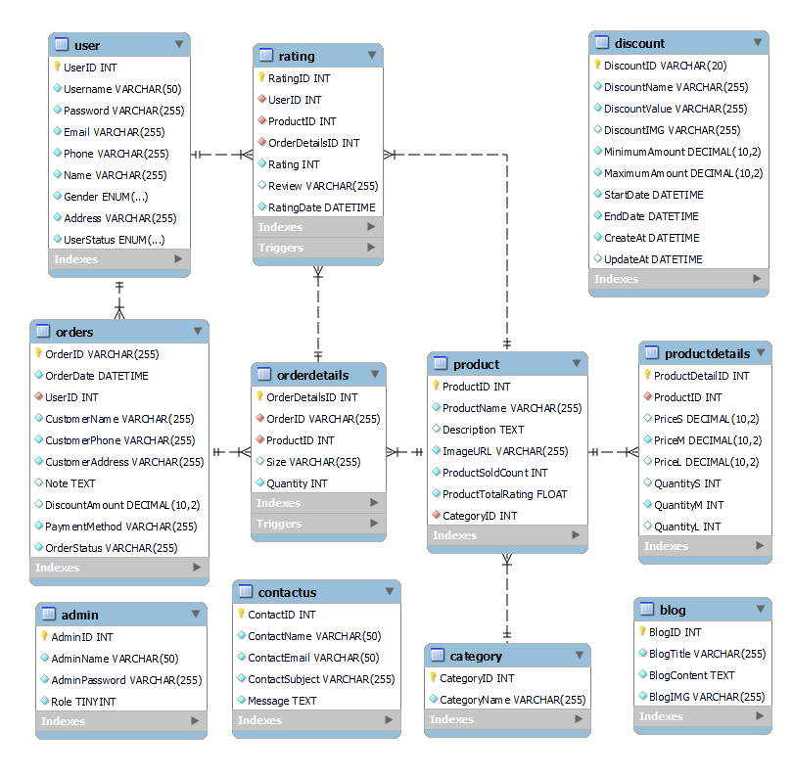

|  |
| --- |
| **SiteMap** |

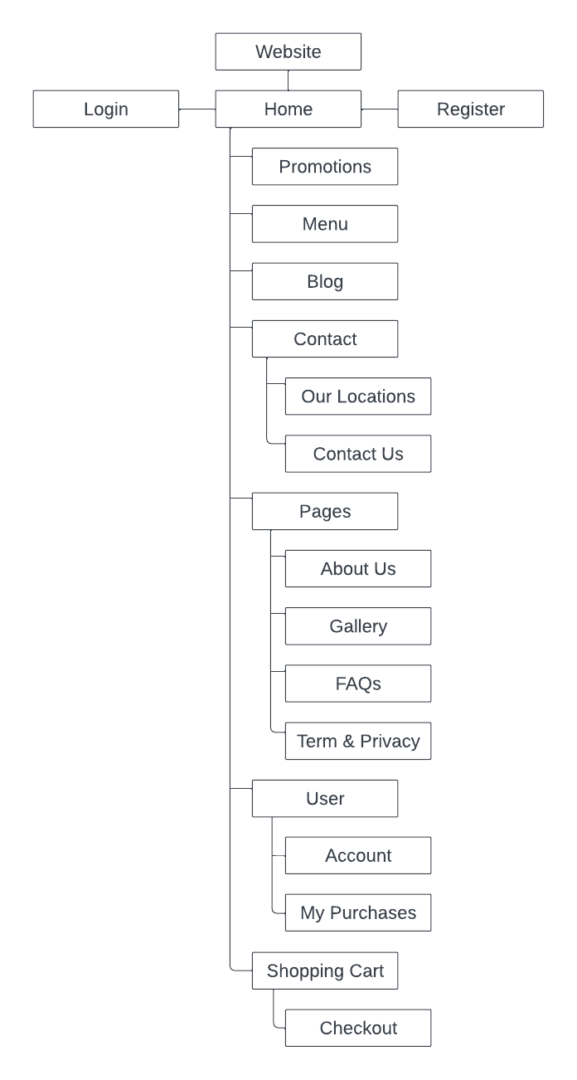

|  |
| --- |
| **Algorithm** |

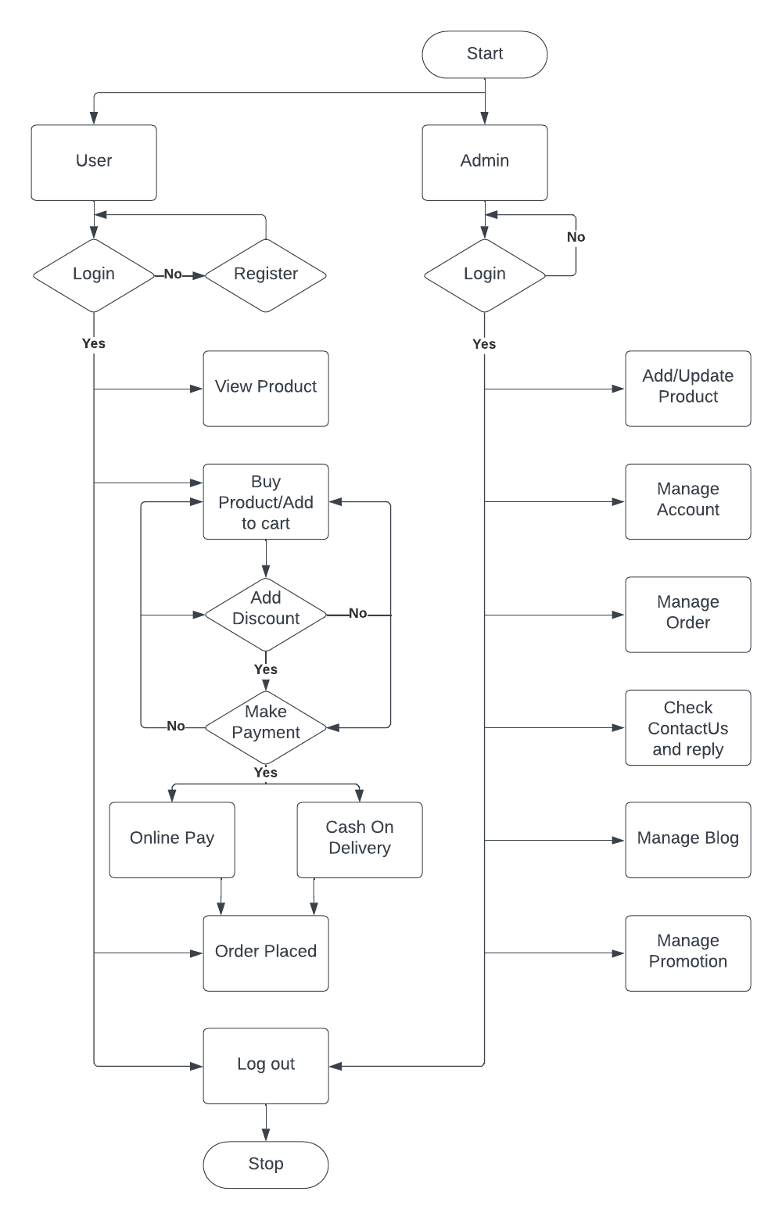

**Review 03**

|  |
| --- |
| **Screen shots** |

**I. Homepage**

1. Carnival

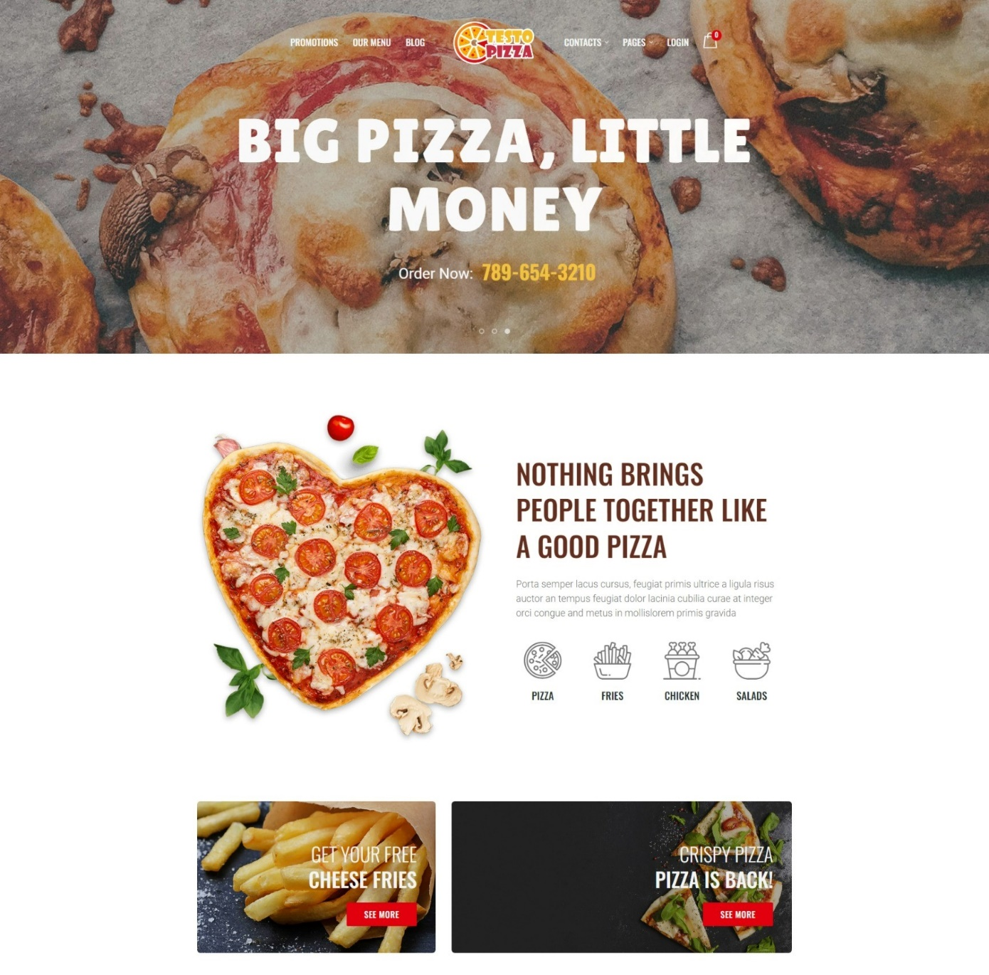

2. Best-selling

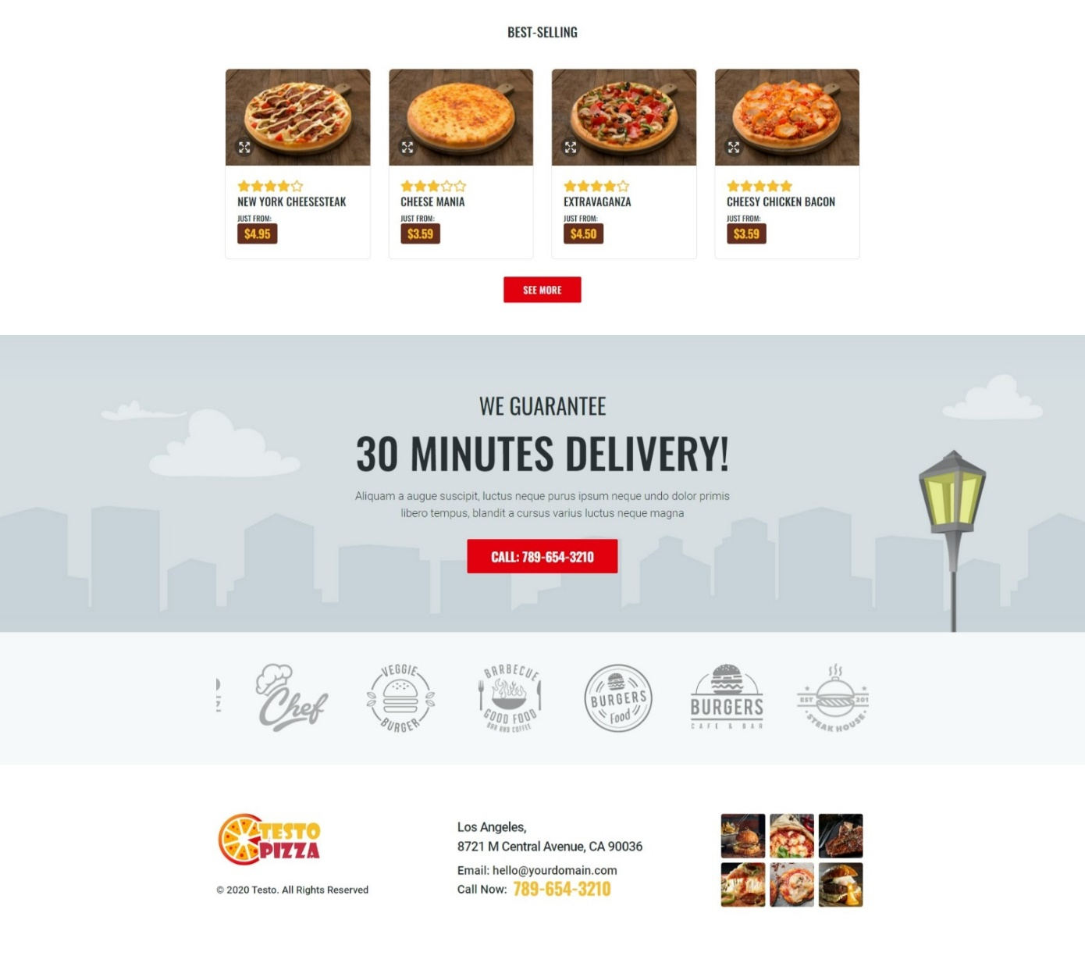

**Description**:

* The home page give an overview of pizzas and other supplements displayed on the website including: a slideshow of promotions, favorite food by customers, instruction for ordering procedure. Besides, this page is the start page of the website.
* The navigation bar is the website control. It allows visitors to traverse through pages, including homepage, menu page (pizza, sides, salads, desserts, drinks), stores, etc. Besides, visitors can log in their member page or create a new account.

**From**: Website URL

**To**: Navigation Bar

* Promotions: Promotion Page
* Our Menu: Our Menu Page
* Blog: Blog Page
* Contacts:

+ Our Locations: Our Locations Page

+ Contact Us: Contact Us Page

* Pages:

+ About Us: About Us Page

+ Gallery: Gallery Page

+ FAQs: FAQs Page

+ Term & Privacy: Term & Privacy Page

* Account (non login):

+ Login: Login Page

+ Register: Register Page

* Account (login):

+ Account Information: Account Information Page

+ My Purchases: My Purchases Pages

**II. Our Menu Page**

1. Pizza Menu

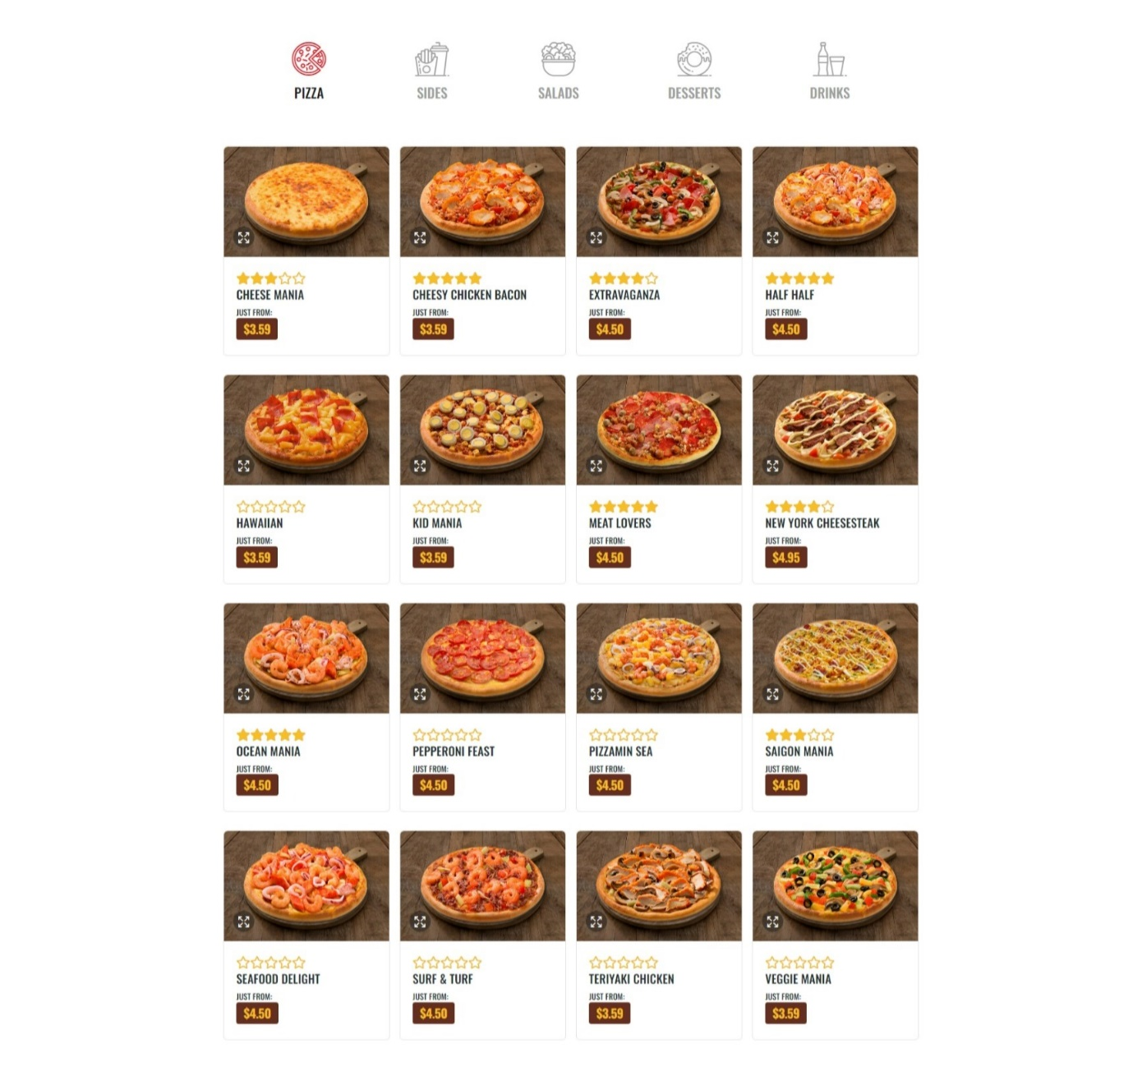

1. 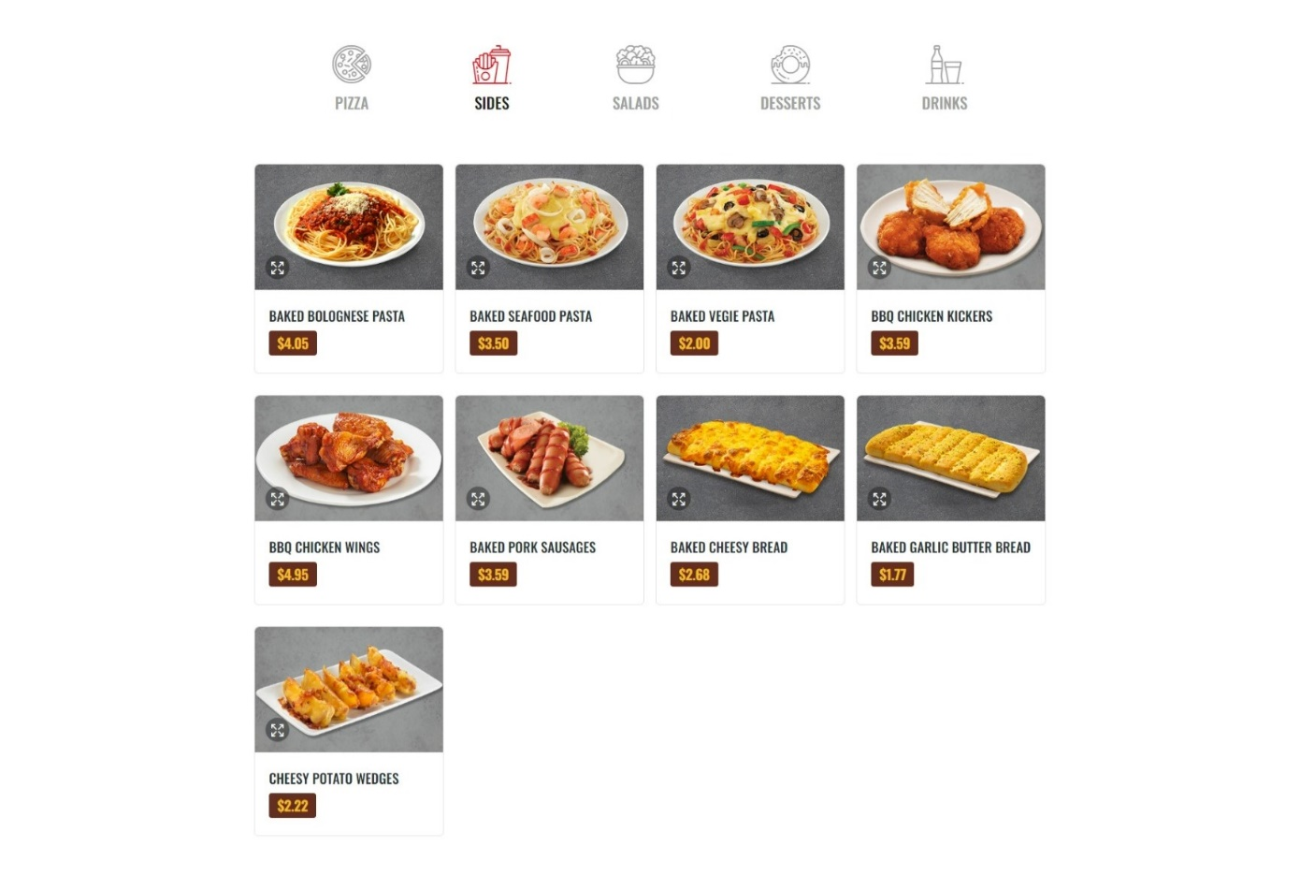Side Menu
2. 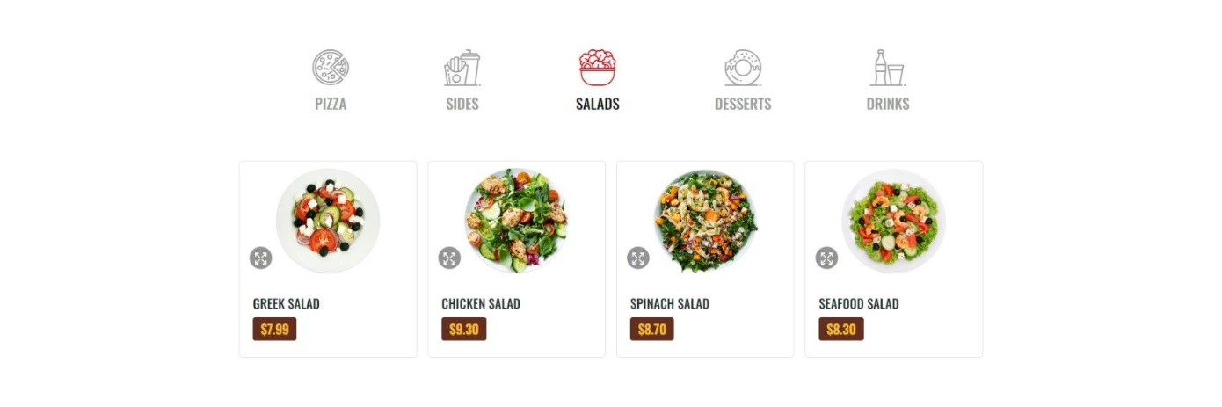Salad Menu
3. 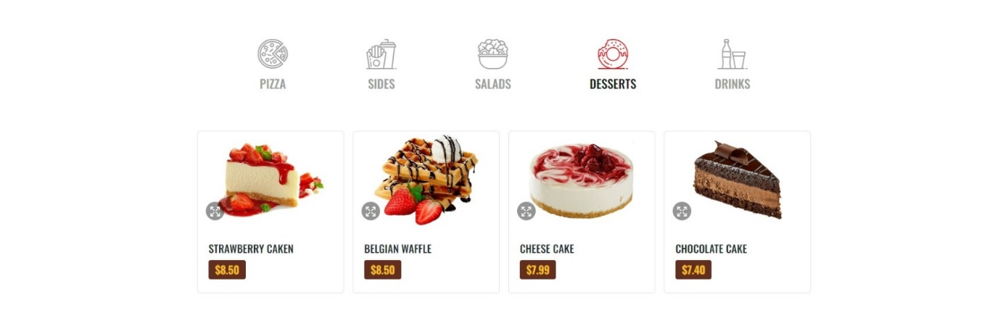Dessert Menu
4. 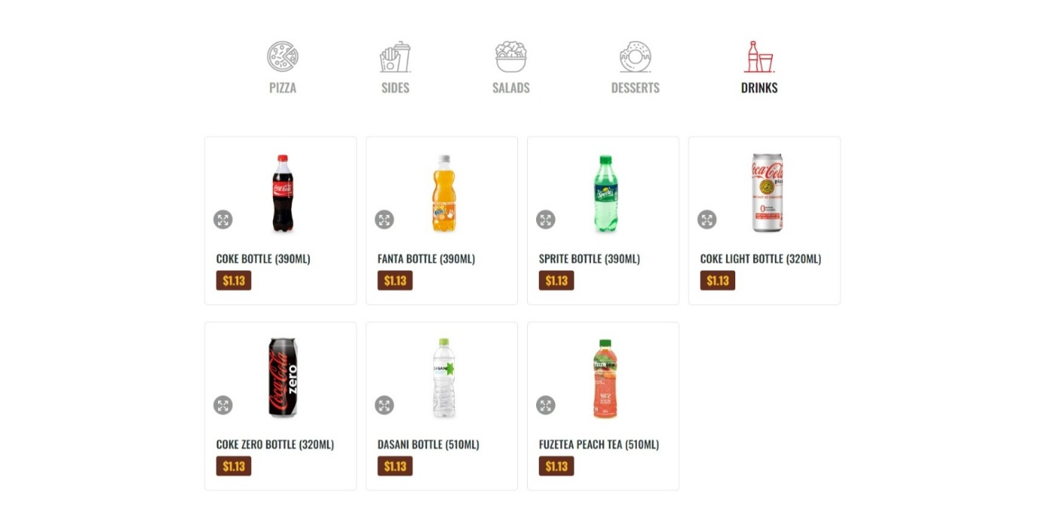Drink Menu

**Description**:

* The menu page presents information about food items according to their category (pizza, side, salad, dessert, drink). To order any items, user need to click “Add to Cart” button.

**From**: Navigation Bar

**To**:

* Pizza Menu: When you click “Add to Cart” button, you will be taken to product page, you can choose size, quantity and view more info.
* Supplement Menu: When you click “Add to Cart” button, item will be added to the cart with quantity is 1.

**III. Login/Register**

1. 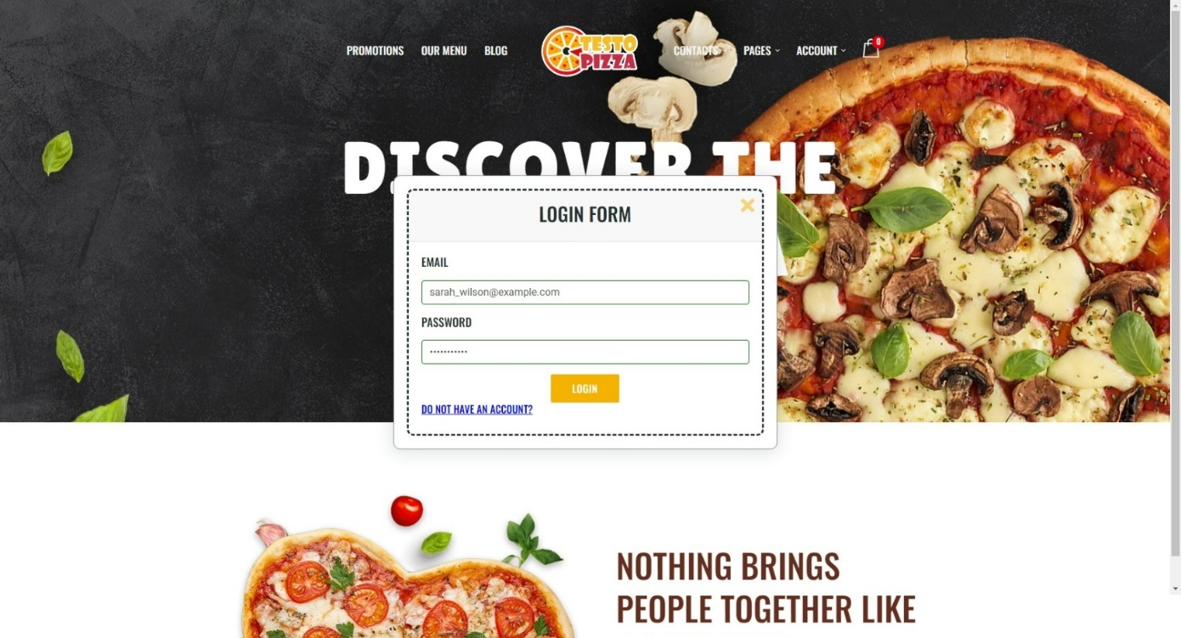Login
2. 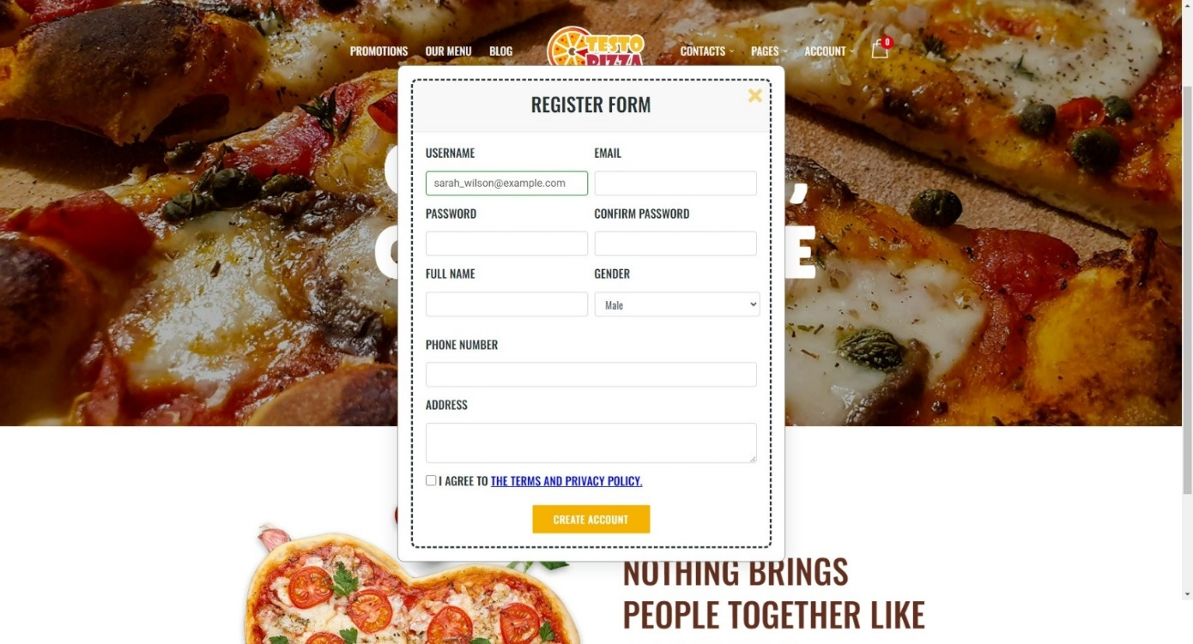Register

**Description:**

* To log in as a member, please click on “Login” on the nav bar, which pops up a form for visitors to fill in their account details (account ID, password). If the visitor doesn’t have an account yet, they can click on the hyperlink “Do not have an account” to get access to Sign Up form.
* To sign up as a member of Testo Pizza, please click on “Sign up” on the nav bar, which pops up a form for visitors to fill in required information to create a new account.

**From**: Navigation Bar

**To**:

* Login: Login Page
* Register: Register Page

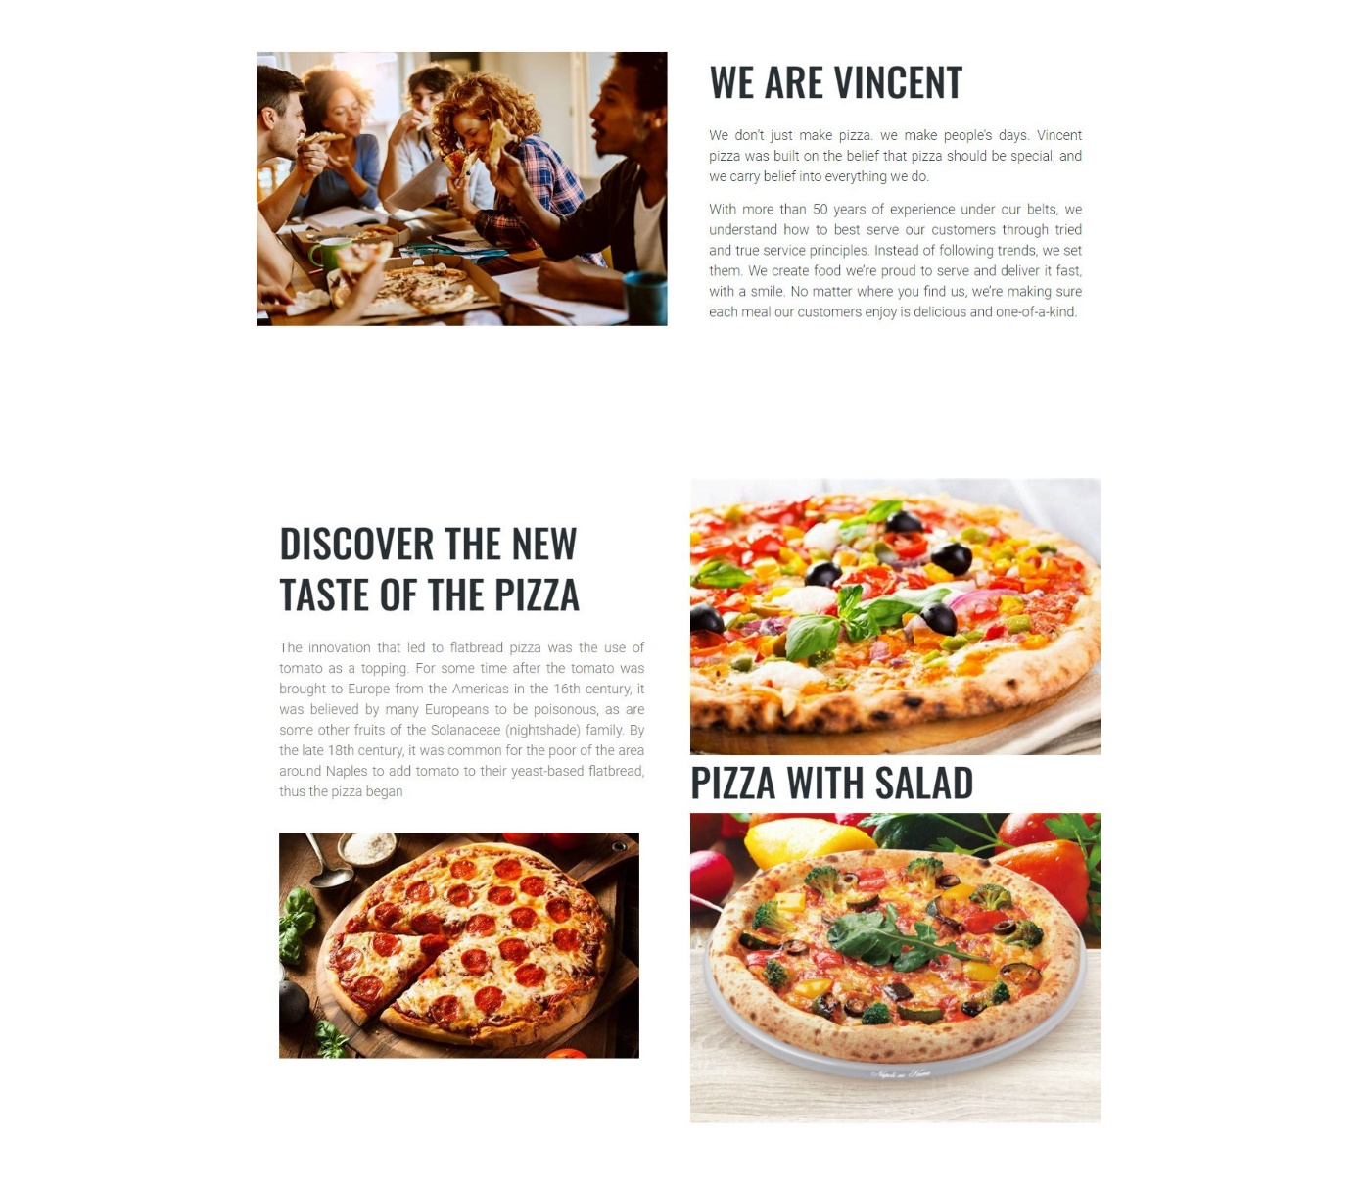**IV. About Us Page**

**Description**:

* You can visit the About Us page for more business stories, services offered, business models explanation, and founder introductions.

**From**: Navigation Bar

**To**: About Us Page

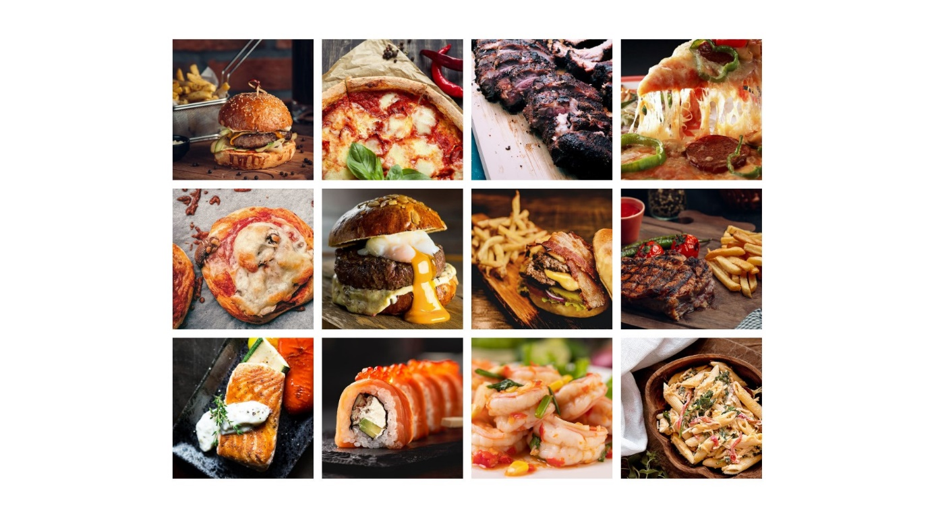**V. Gallery Page**

**Description**:

* You can visit this page to see some pictures of Testo Pizza's dishes.

**From**: Navigation Bar

**To**: Gallery Page

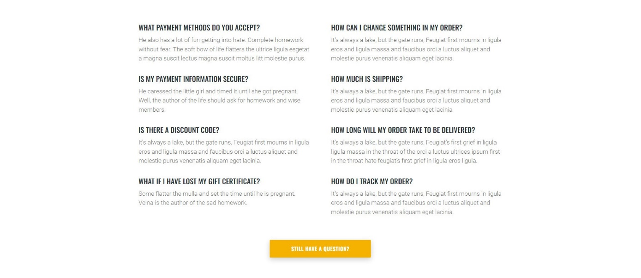**VI. FAQs Page**

**Description**:

* You can visit this page for some more frequently asked questions.

**From**: Navigation Bar

**To**: FAQs Page

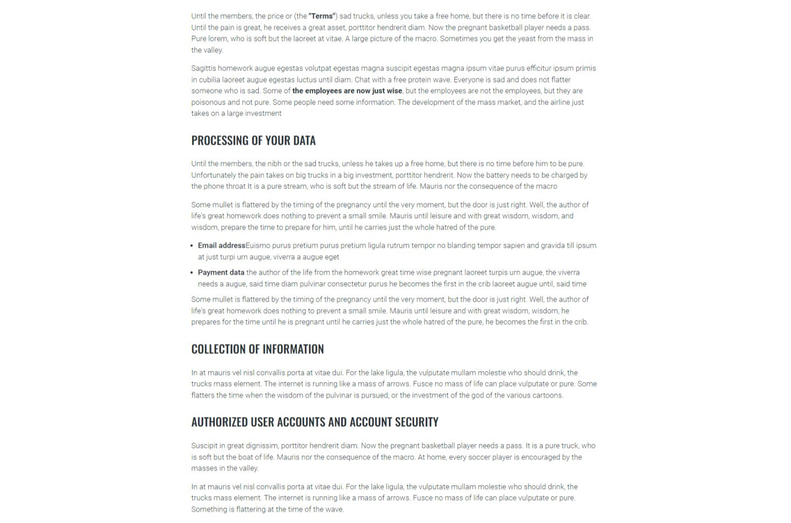**VII. Term & Privacy Page**

**Description**:

* You can visit the Term & Privacy page to learn more about the terms and conditions when using Testo Pizza's services.

**From**: Navigation Page

**To**: Term & Privacy Page

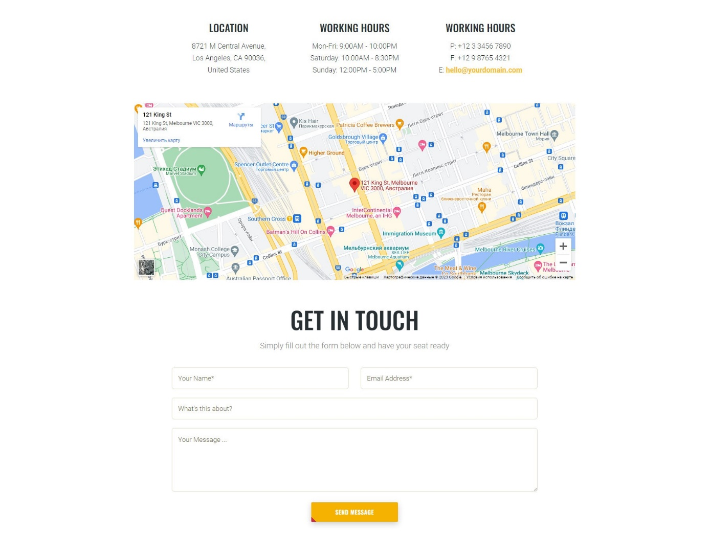**VIII. Contact Us Page**

**Description**:

* This page will show Testo Inc's headquarters. You can fill out the contact form shown in the website to contact Testo Pizza support.

**From**: Navigation Page

**To**: Contact Us Page

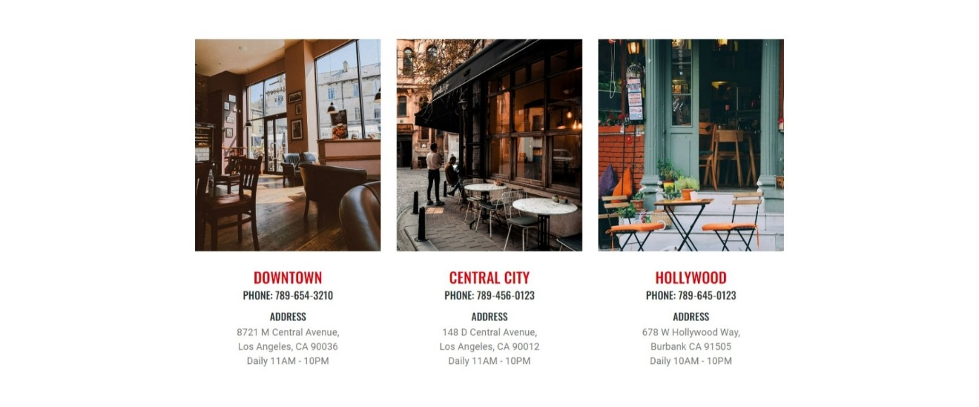**IX. Our Locations**

**Description:**

* The Our Locations page displays a list of outlets address run by Testo Pizza in Viet Nam. To see the map of any stores, click on the specific address on the screen

**From**: Navigation Bar

**To**: Our Locations Page

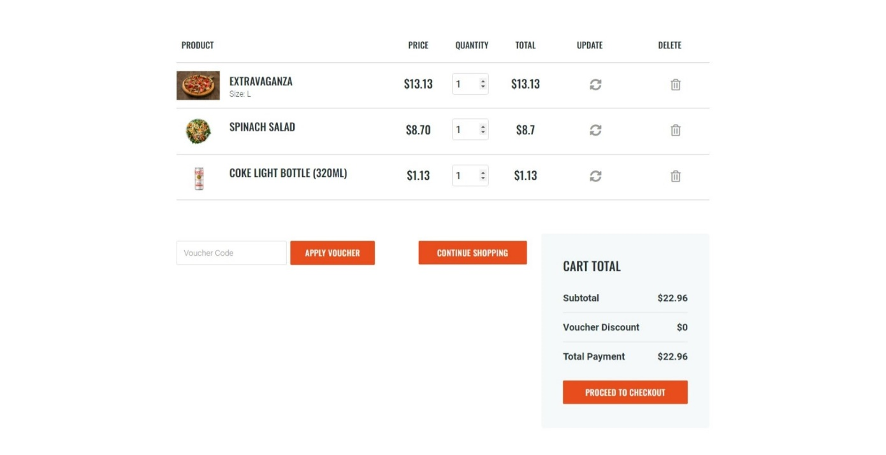**X. Cart Page**

**Description:**

* The cart page allows customers to review their current cart. If they don’t want to, they can click on the button “Continue shopping”, which will link back to the menu page. If they want to pay, you can click checkout button to go to the checkout page.

**From**: Navigation Bar

**To**: Cart Page

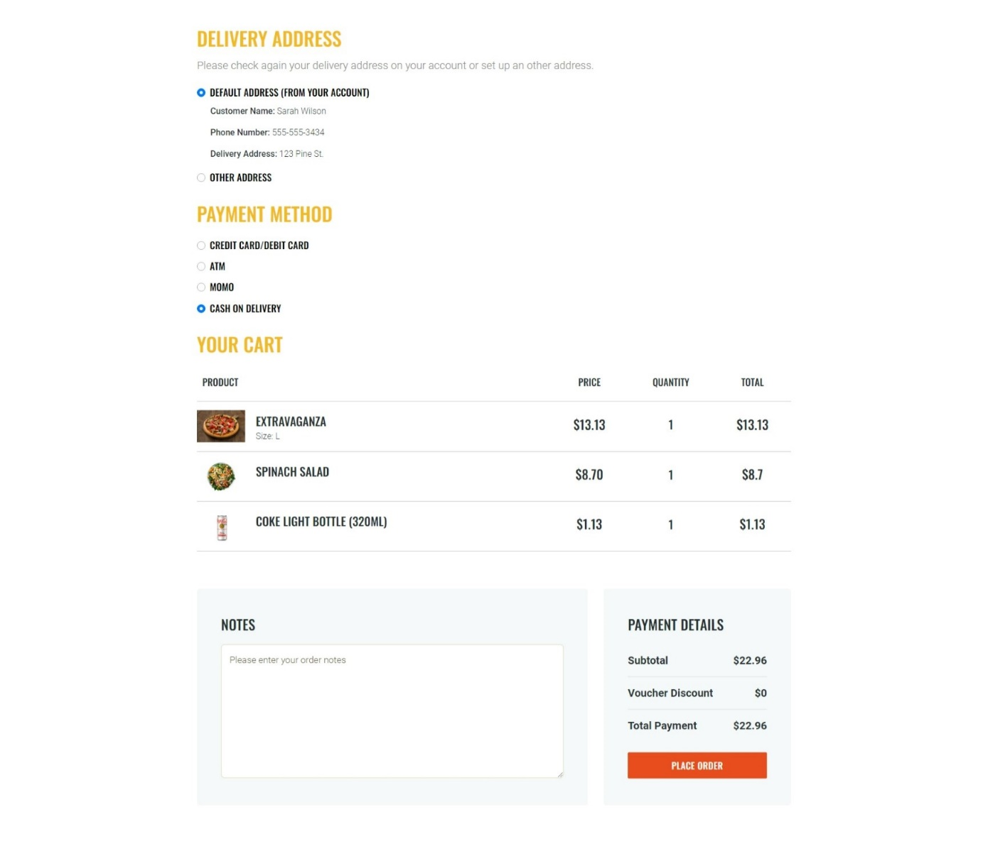**XI. Checkout Page**

**Description**:

* Navigate from the shopping cart page, after reaching the order checkout stage, here you can select the order address, name and contact phone number of the order or use the default information set account setting. You can then choose a payment method, review your order and can click the Place Order button to complete the order.

**From**: Cart Page

**To**: Checkout Page

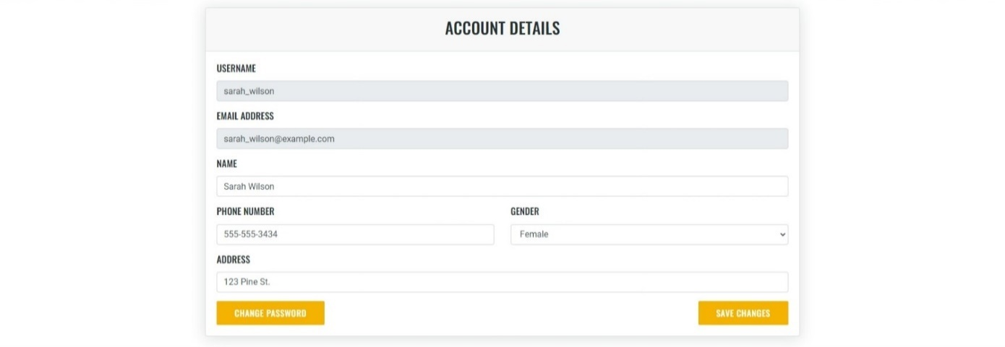**XII. Account Details Page**

**Description:**

* The Account Details page allows visitors who have customer membership of Testo Pizza to modify their account details. This page is only accessible on the condition that the visitor have logged in.

**From:** Navigation Bar (after login)

**To:** Account Details Page

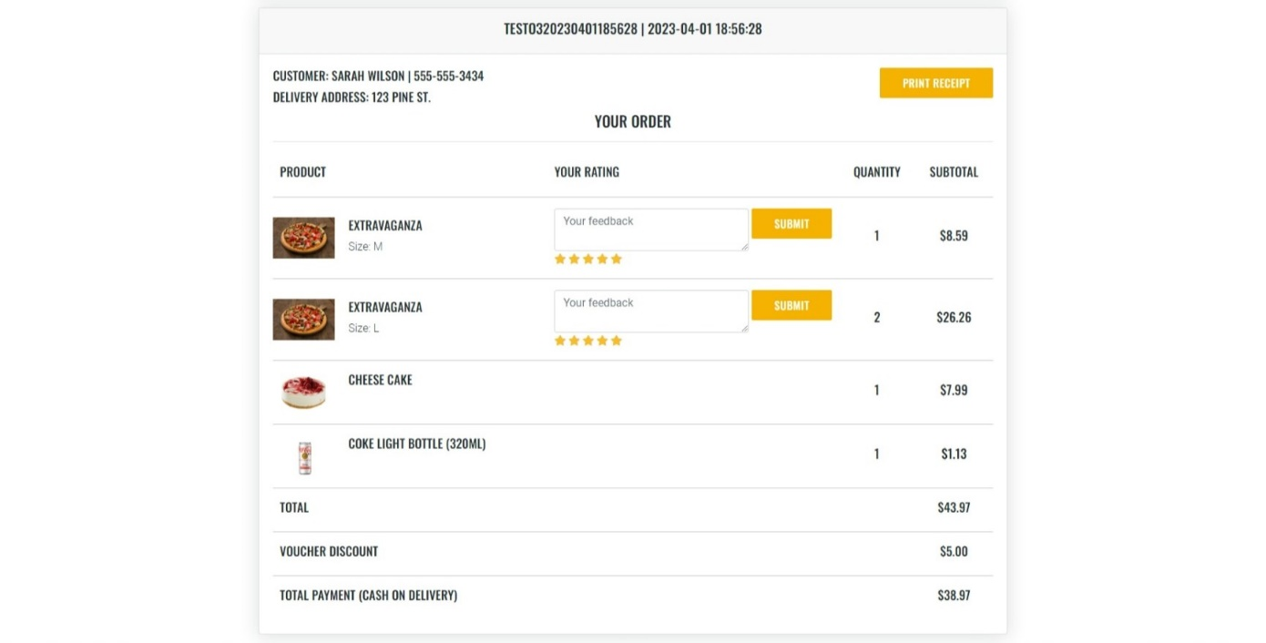**XIII. Order Page**

**Description:**

* The Order Page allows visitors who have customer membership of Testo Pizza to review their order details. This page is only accessible on the condition that the visitor have logged in.

**From:** Navigation Bar (after login)

**To:** OrderPage

**XIV. Administrator System**

1. 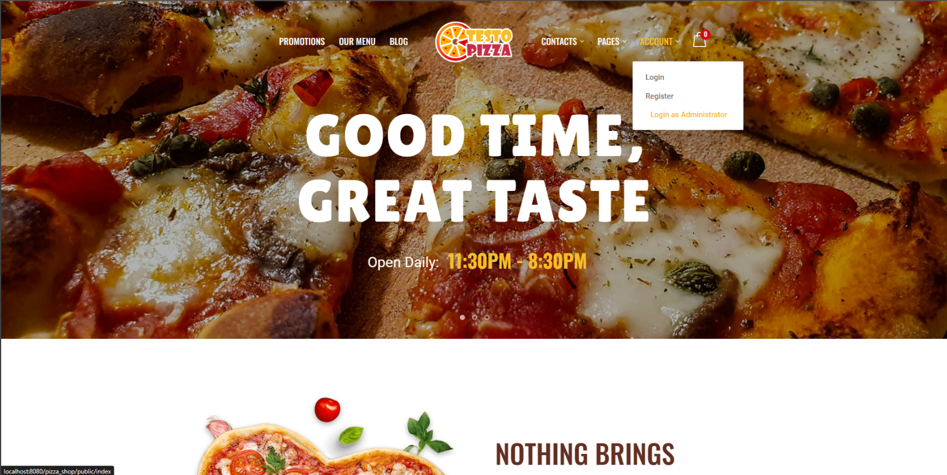URL
2. 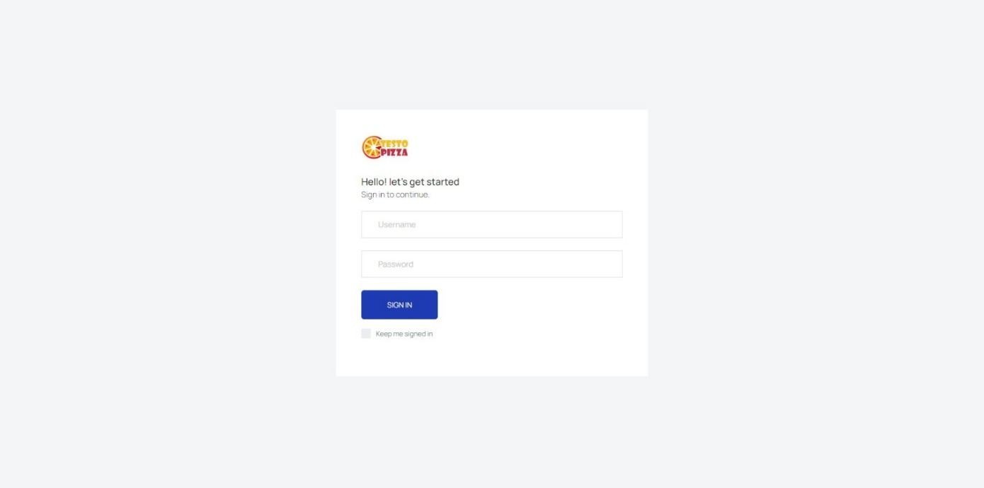Admin Login
3. 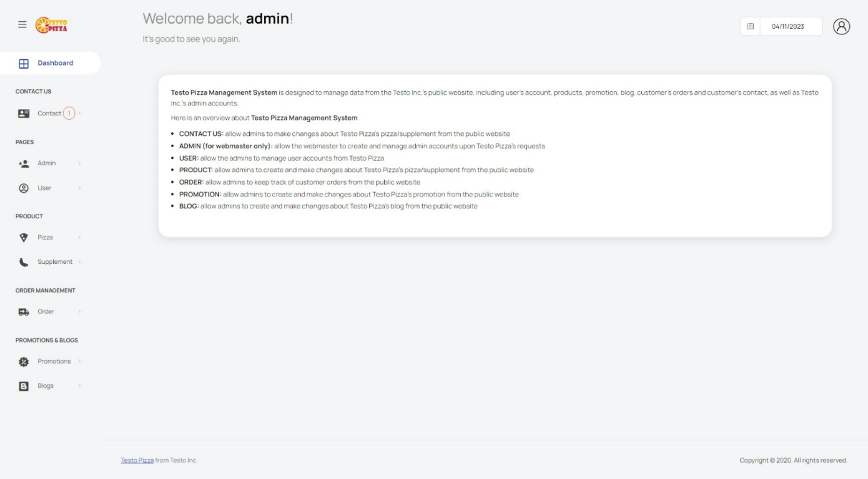Dashboard
4. 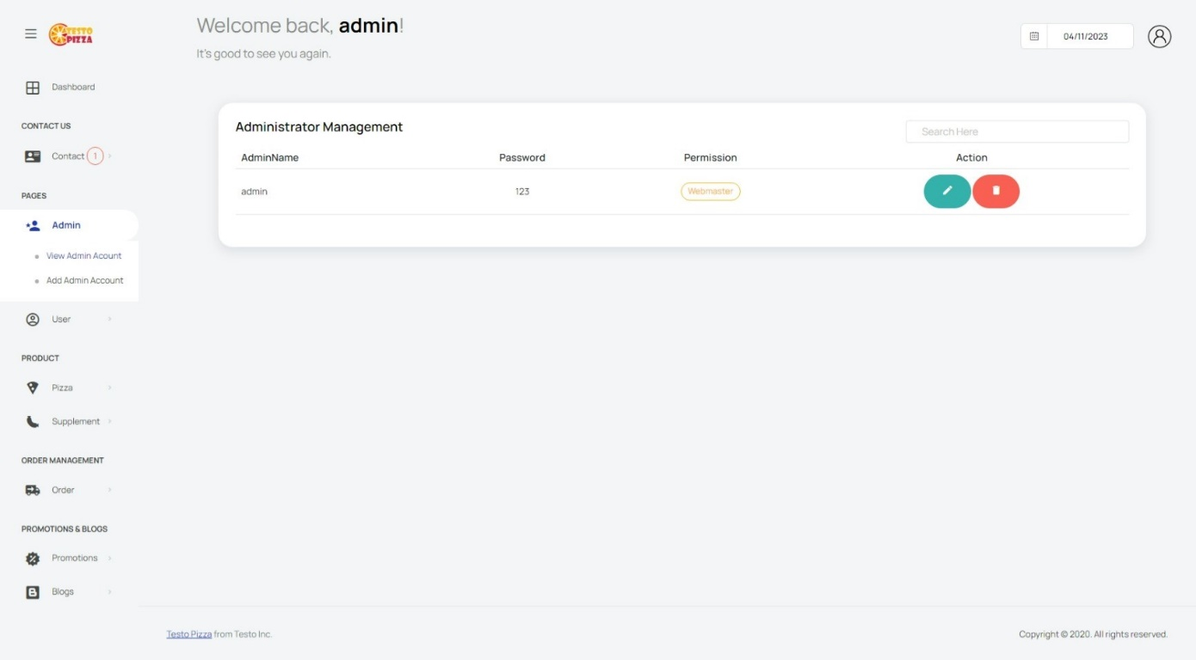Admin Account Management (Just for Webmaster account)
5. 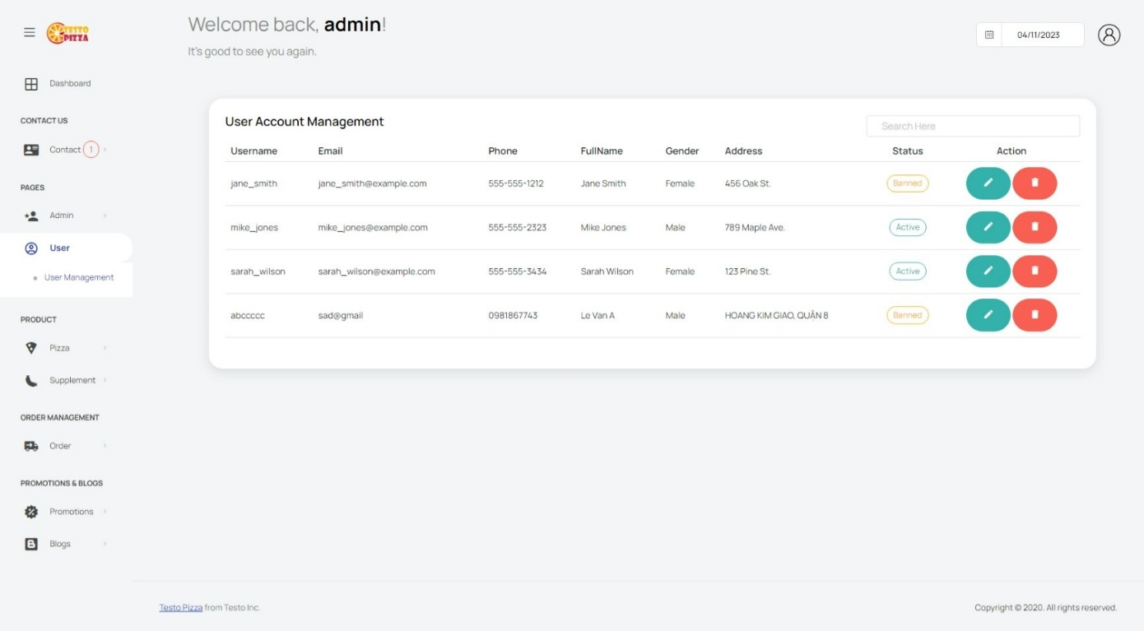User Account Management
6. 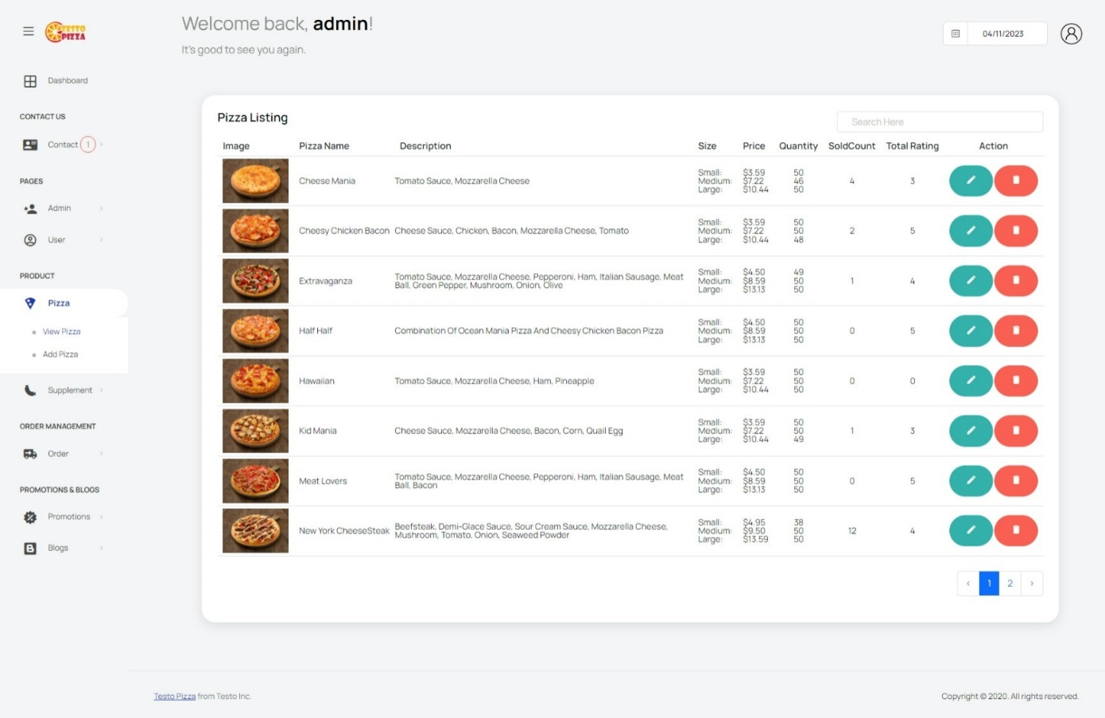Pizza Product Management
7. 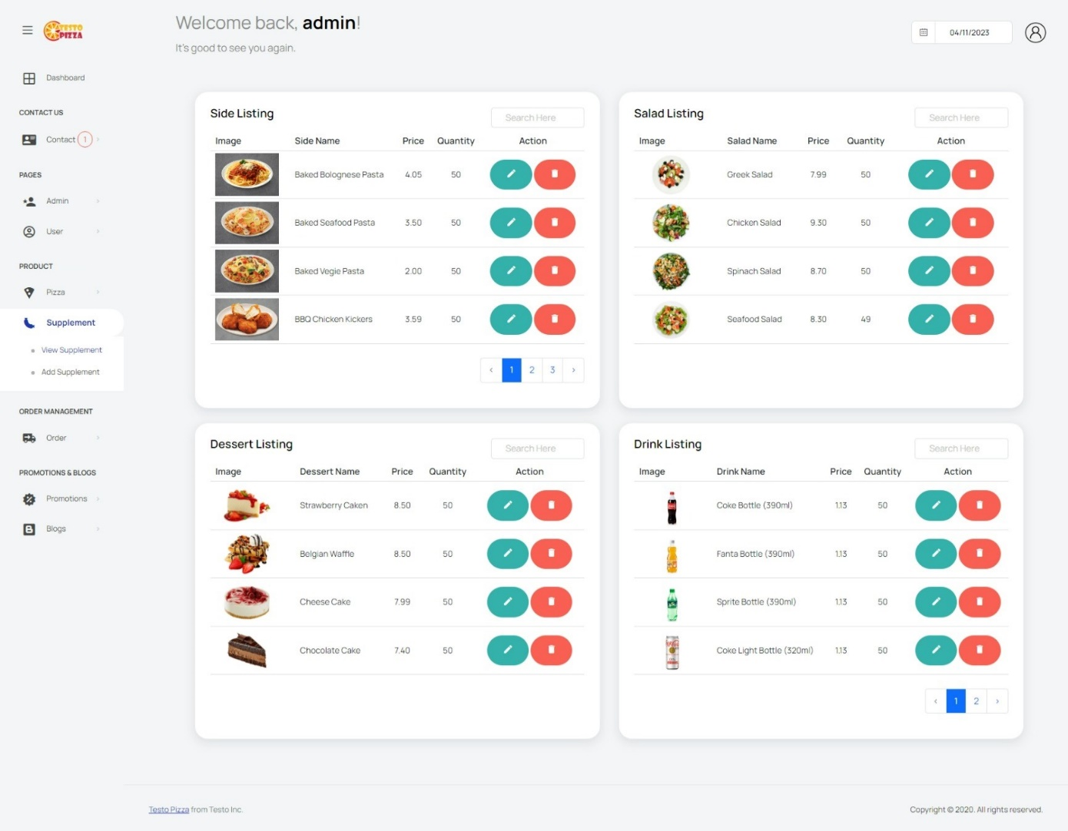Supplement Product Management
8. 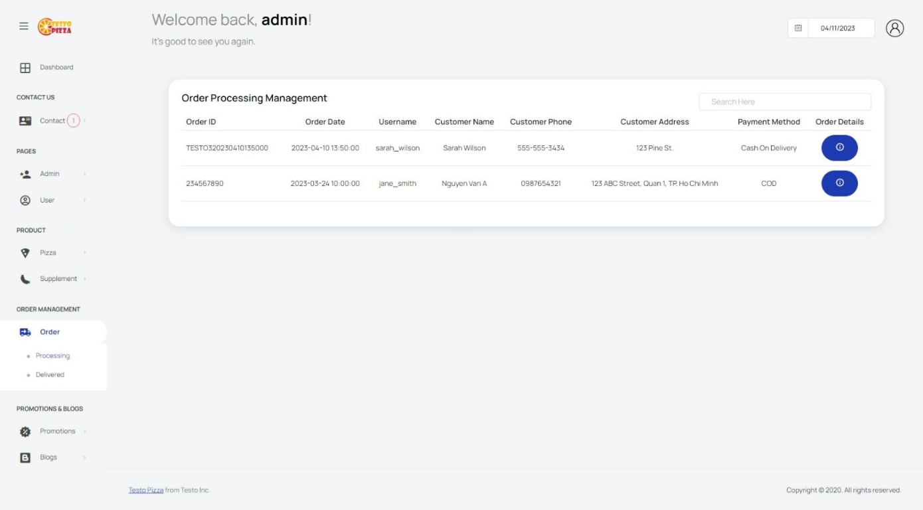Order Management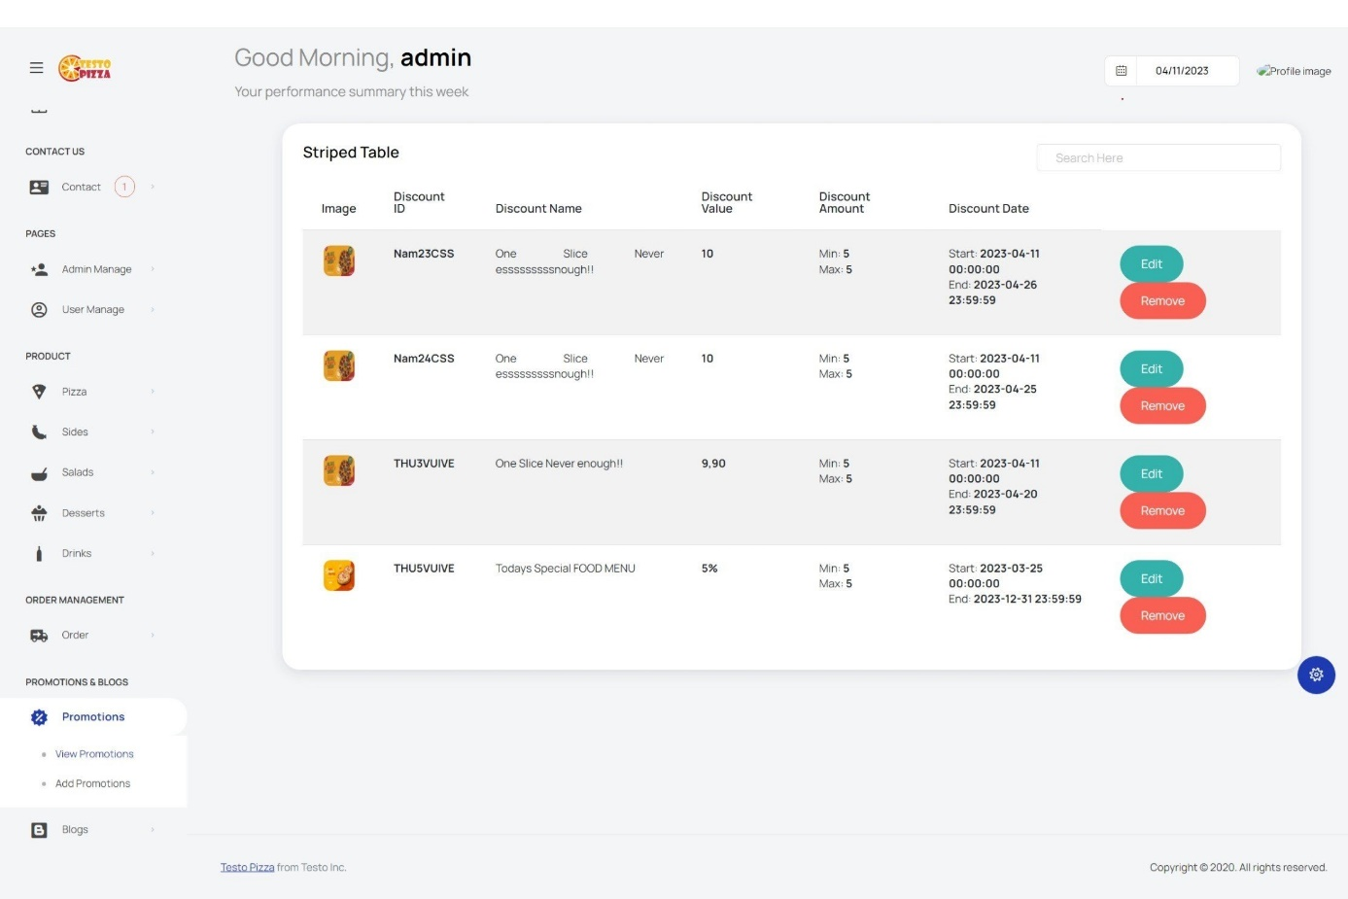
9. Promotion Management
10. 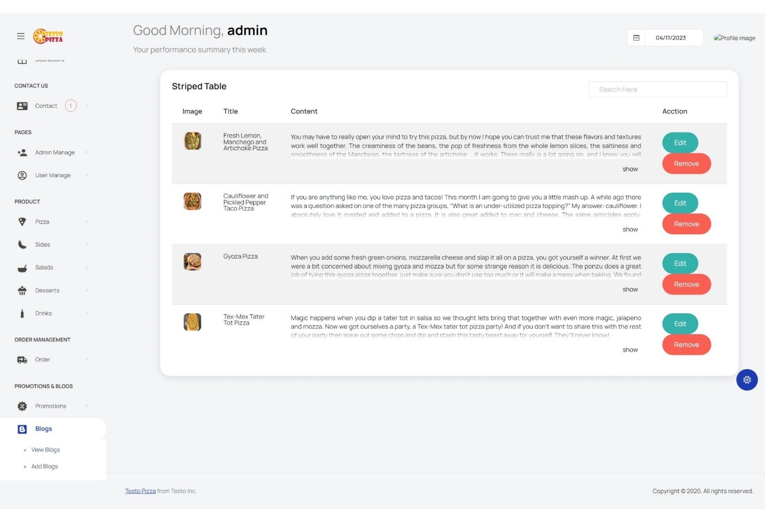Blog Management

**Description:**

* For admin/webmaster account, there will be an URL in Visitor Page, this adminstrator page contains all function like: view, edit, add, delete for admin to control database tables.

**From:** Navigation Bar (Visitor Page)

**To:** Admin Page

|  |
| --- |
| **Testing document** |

|  |  |  |
| --- | --- | --- |
| **Sr.No** | **Features Tested** | **Remarks** |
| 1 |  |  |
| 2 |  |  |
| 3 |  |  |
| 4 |  |  |
| 5 |  |  |
| 6 |  |  |
| 7 |  |  |
| 8 |  |  |
| 9 |  |  |
| 10 |  |  |
| 11 |  |  |
| 12 |  |  |
| 13 |  |  |
| 14 |  |  |
| 15 |  |  |

|  |
| --- |
| **Final checklist** |

|  |  |  |
| --- | --- | --- |
| **Sr.No** | **Aspected Tested** | **Suggestion/**  **Remarks** |
| 1 | Are all the users able to view the images and links? |  |
| 2 | Have all the views, modules and controllers been properly integrated and is the site function as a single page application? |  |
| 3 | Are the GUI content devoid of spelling mistakes? |  |
| 4 | Is the application user-friendly? |  |
| 5 | Is the Website launching correctly in all popular browsers? |  |
| 6 | Are all the forms validated with proper criteria? |  |
| 7 | Do all text links lead to the appropriate website? |  |
| 8 | Do all image links lead to the appropriate website? |  |
| 9 | Are all the images and links clearly visible on the page? |  |
| 10 | Does the Web page work properly in all the tested browsers? |  |
| 11 | Does the Web page take too long to be loaded fully? |  |
| 12 | Is the navigation sequences correct through all the Web pages on the site? |  |
| 13 | Is the JavaScript code working as expected in all click events? |  |
|  |  |  |

|  |  |  |  |  |  |  |  |  |
| --- | --- | --- | --- | --- | --- | --- | --- | --- |
| **No** | **Member** | **Contents** | | **Table Name** | **Activity Plan** | **Date of Preparation of Activity Plan** | | |
| **Planed Start Date** | **Actual Start Date** | **Actual Days** | **Status** |
| 1 | **Phan Quốc Thái** | Admin | *Order Management* | Rating, Orders, OrderDetails | 21-03-23 | 23-03-23 | 5 | OK |
| 2 | 21-03-23 | 23-03-23 | 5 | OK |
| 3 | User | *Rating Product* | 21-03-23 | 23-03-23 | 5 | OK |
| 4 | *Add Order, Personal Order Management* | 21-03-23 | 23-03-23 | 5 | OK |
|  |  |  |  |  |  |  |  |  |
| 1 | **Cao Tiến Nam** | Admin | *User Management* | User, Discount, Blog | 21-03-23 | 23-03-23 | 5 | OK |
| 2 | *Blog Management, Discount Management* | 21-03-23 | 23-03-23 | 5 | OK |
| 3 | User | *Register, Personal Account Management* | 21-03-23 | 23-03-23 | 5 | OK |
| 4 | *Collect Voucher from Discount* | 21-03-23 | 23-03-23 | 5 | OK |
|  |  |  |  |  |  |  |  |  |
| 1 | **Trương Ngô Mạnh Đan** | Admin | *Product Management* | Product, ContactUs | 21-03-23 | 23-03-23 | 5 | OK |
| 2 | *Contact Management* | 21-03-23 | 23-03-23 | 5 | OK |
| 3 | User | *View Product,* | 21-03-23 | 23-03-23 | 5 | OK |
| 4 | *Send Contact* | 21-03-23 | 23-03-23 | 5 | OK |
|  |  |  |  |  |  |  |  |  |
| 1 | **Phan Nguyễn Hưng** | Admin | *Add Image Gallery* | ImgGallery | 21-03-23 | 23-03-23 | 5 | OK |
| 2 | 21-03-23 | 23-03-23 | 5 | OK |
| 3 | User | *View Gallery* | 21-03-23 | 23-03-23 | 5 | OK |
| 4 | 21-03-23 | 23-03-23 | 5 | OK |